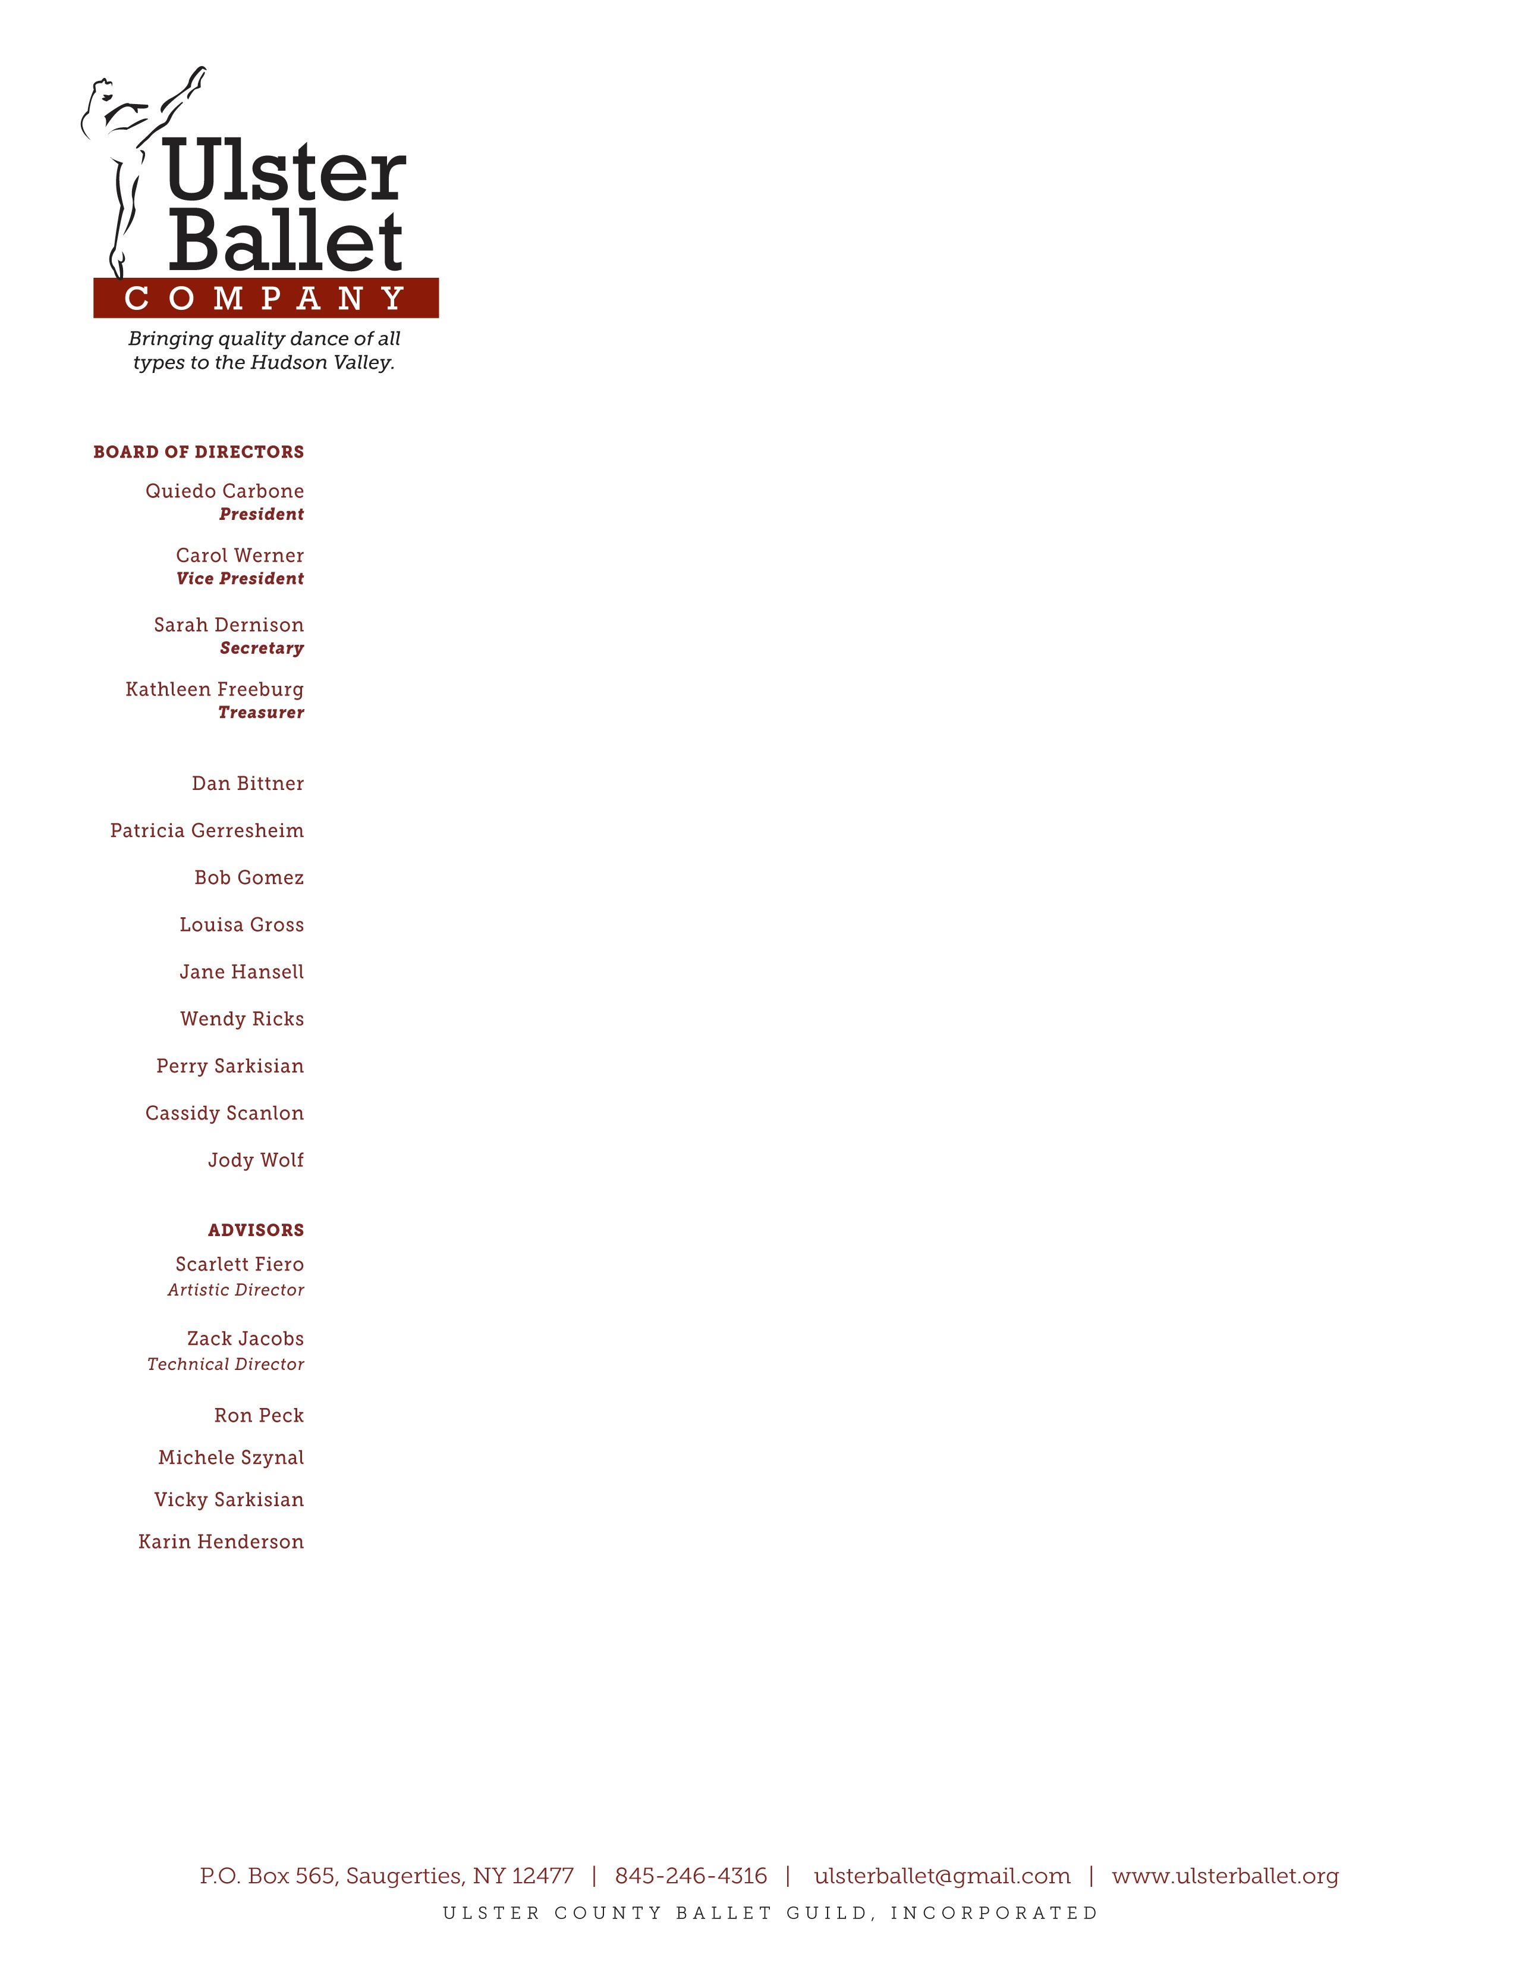

Type to enter text

October 22, 2015

Dear Sirs,

Fdjfdhljkfdkljfdkjlfhdk